BIOE 301 Name:
Exam 2
March 9, 2006

The exam consists of 7 questions. Show all work to receive credit. Clearly organize your work and draw a box around your final answers. NEATNESS COUNTS! Good Luck!

Problem 1 (20):

Problem 2 (10):

Problem 3 (20):

Problem 4 (10):

Problem 5 (10):

Problem 6 (10):

Problem 7 (20):

t-shirt points (2):

Extra Credit (2):

Total (100):

- You are a physician for Mr. Jones, a 65 year old African American man who presents to you with complaints of difficulty urinating. Specifically, he has trouble starting urine flow and has an intermittent stream. He says he noticed this problem some time ago, and that it has slowly been getting worse. Mr. Jones says he has always been healthy and has not seen a doctor in thirty years. He was adopted and does not know his family history.

  - What disease that we’ve talked about in class might explain Mr. Jones’ symptoms?
Prostate cancer

  - What three risk factors for this disease does Mr. Jones have?
age (65), sex (male), race (African American)

  - What initial tests are available that might aid your diagnosis of Mr. Jones? There are two that we discussed in class.
DRE (digital rectal exam) or serum PSA (prostate specific antigen)

  - If the initial tests are positive, what would be the next step in diagnosis?
biopsy

  - Mr. Jones does indeed have the disease you suspected, and you recommend surgical intervention. Any surgical procedure has the risks of pain, bleeding, and infection. What are two specific risks talked about in class that are associated with this particular surgery?
impotence, incontinence, infertility

  - List two reasons discussed in class why the tests listed in part c are controversial for use as screening tools.
May identify cancers that will never produce symptoms
May produce many false positive diagnoses – following these up is expensive, painful and causes emotional distress to patients

  - In American males, prostate cancer is the most common, non-skin cancer (accounting for 33% of all new cancers), but is less deadly than might be expected, ranking behind both lung and colon cancer as the third leading cause of cancer death (9%). By contrast, ovarian cancer is the eighth most common new non-skin cancer in American women (3% of new diagnoses), but accounts for a surprising number of deaths; it ranks as the fifth leading cause of cancer death in this population (6%). Give three reasons for the discrepancy between the incidence and death rates for these two cancer types.
- Prostate cancer is very slow growing and metastasizes late, whereas ovarian cancer grows and metastasizes more quickly
- prostate cancer is often symptomatic while still localized, whereas ovarian cancer causes non-specific symptoms and is often diagnosed at an advanced stage
- prostate cancer is very slow-growing and occurs late in life, so patients are likely to die of other disease processes rather than the cancer
- there are good screening techniques for prostate cancer, so it can be caught at an early stage, while ovarian cancer is currently difficult to screen for
- We discussed a variety of tests to screen for cancer and to confirm a diagnosis of cancer.

  - Tissue biopsies are analyzed histologically to diagnose the presence of cancer and precancer. Name a common morphologic trait consistent with a diagnosis of precancer.

Enlarged nucleus
Elevated nuclear to cytoplasmic ratio
Variations in nuclear size and shape

  - Below is a classic diagram which illustrates the progression of cancer:
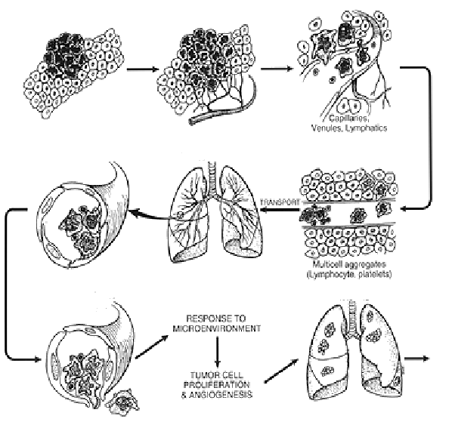
A
B
C
D
Label steps A, B, C & D in the diagram. Explain in one sentence what happens in each step.

A: transformation and clonal expansion: A single cell becomes transformed; the cell divides giving rise to a focus of tumor cells.
B: angiogenesis: Tumor cells recruit development of new blood vessels to supply nutrients.
C: extravasation: Tumor cells travel through the blood stream or lymphatic vessels; they attach to vessel walls downstream, and migrate to surrounding tissue to produce a micrometastasis.
D: metastasis: Transformed cells divide in a distant organ site creating a new tumor.
- Answer the following questions about pathogens, the immune system, and vaccines.

  - Check to indicate pathogen type(s) for which each statement applies.

Trait | Bacteria | Virus
Uses host cellular machinery to reproduce |  | X
Can be killed or inhibited by antibiotics | X
Short pathogen peptide sequences are displayed in MHC surface receptors. | X | X
Living cells, usually having both a membrane and cell wall | X
Protein capsid houses nucleic acid core |  | X
Can reproduce without a host | X
Tens of nanometers in size |  | X

  - How can T cells identify cells infected with viruses?

Cells display viral protein fragments on MHC proteins. T-cells bind and become activated by MHC receptors displaying foreign peptide sequences.

  - Antigen binding to B-cell surface receptors and interaction with activated helper T cells activates B-cells to produce and secrete antibodies. Compare the onset and magnitude of the B-cell response for primary (initial) and secondary (subsequent) exposure to a particular antigen.

The primary response is characterized by a lag phase, during which naïve B cells undergo clonal selection, expansion, and finally differentiation into both memory and plasma cells. Ab secretion is not possible until the plasma cell have been produced. Peak plasma Ab levels occur about 14 days after exposure. The secondary response has a shorter lag period, reaches a greater magnitude, and lasts longer. The secondary response is also characterized by secretion of antibodies with a higher affinity for the antigen, and isotypes other than IgM predominate.

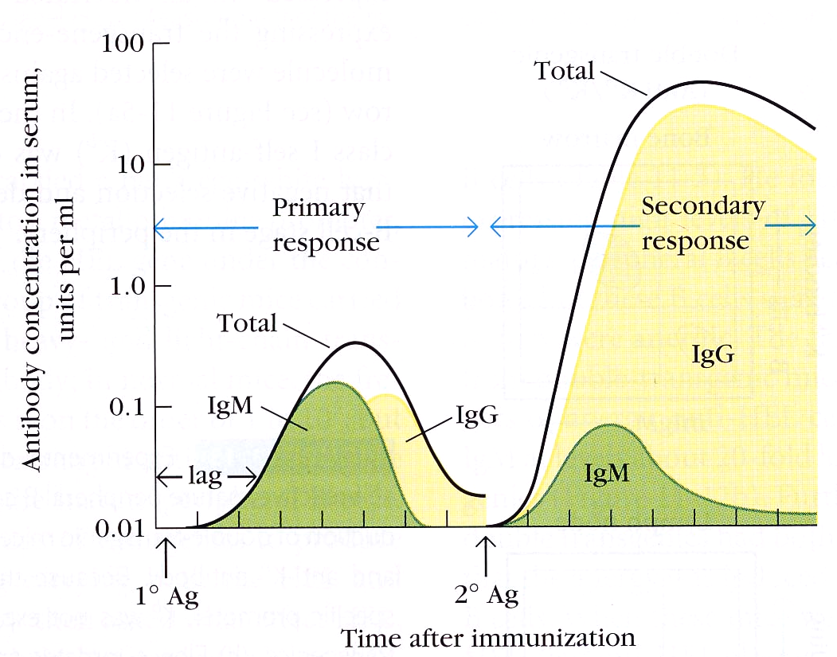

  - Identify the following vaccine types from the provided descriptions. Circle the one that is likely to confer life long immunity.

___________________: The pathogen is treated with chemicals or irradiated. The early version of the polio vaccine and the rabies vaccine are examples.

___________________: Mutations have been introduced to the pathogen. This form is used to prevent measles, mumps and rubella.

Non-infectious (Killed bacterial or inactivated viral)
Live, attenuated vaccines (should be circled)

  - Fill in the blanks.

_____________________ was the first human disease eradicated through a global immunization campaign. The strategy was to vaccinate 80% of the population and provide surveillance and containment of local outbreaks. The campaign made use of _____________________ in which non-immunized individuals benefit from others’ inability to contract and transmit the disease.

Smallpox, herd immunization
- The following text contains portion of an article which appeared in the Austin American Statesman last year. Read the text and answer the following questions.

Federal researchers tested AIDS drugs on foster children without advocate protections

At least seven states, including Texas, participated in studies, which are now under investigation.
By John Solomon ASSOCIATED PRESS Thursday, May 05, 2005
WASHINGTON — Government-funded researchers tested AIDS drugs on hundreds of foster children over the past two decades in at least seven states, including Texas, often without providing them a basic protection afforded in federal law and required by some states, an Associated Press review has found. The research funded by the National Institutes of Health was most widespread in the 1990s as foster care agencies sought treatments for their HIV-infected children that weren't yet available in the marketplace. The practice ensured that foster children — mostly poor or minority — received care from world-class researchers at government expense, slowing their rate of death and extending their lives. But it also exposed a vulnerable population to the risks of medical research and drugs that were known to have serious side effects in adults and for which the safety for children was unknown.
Several studies that enlisted foster children reported that patients suffered side effects such as rashes, vomiting and sharp drops in infection-fighting blood cells as they tested antiretroviral drugs to suppress AIDS or other medicines to treat secondary infections. In one study, researchers reported a "disturbing" higher death rate among children who took higher doses of a drug. That study was unable to determine a safe and effective dosage. Research and foster agencies declined to make foster parents or children in the drug trials available for interviews, or to provide information about individual drug dosages, side effects or deaths, citing medical privacy laws. Some foster children died during studies, but state or city agencies said they could find no records that any deaths were directly caused by experimental treatments.
The government provided special protections for child wards in 1983. They required researchers and their oversight boards to appoint independent advocates for any foster child enrolled in a narrow class of studies that involved greater than minimal risk and lacked the promise of direct benefit. Some foster agencies required the protection regardless of risks and benefits. Advocates must be independent of the foster care and research agencies, have some understanding of medical issues and "act in the best interests of the child" for the entirety of the research, the law states.
However, researchers and foster agencies said foster children in AIDS drug trials often weren't given such advocates even though research institutions many times promised to do so to gain access to the children. Illinois officials say they think none of their nearly 200 foster children in AIDS studies got independent monitors even though researchers signed a document guaranteeing "the appointment of an advocate for each individual ward participating in the respective medical research." New York City could find records showing 142 — less than a third — of the 465 foster children in AIDS drug trials got such monitors even though city policy required them. The city has asked an outside firm to investigate.
Researchers typically secured permission to enroll foster children through city or state agencies. They frequently exempted themselves from appointing advocates by concluding the research carried minimal risk and the child would directly benefit because the drugs had already been tried in adults. If they decline to appoint advocates under the federal law, researchers and their oversight boards must conclude that the experimental treatment affords the same or better risk-benefit possibilities than alternate treatments already in the marketplace. They also must abide by any additional protections required by state and local authorities.
Many of the studies that enrolled foster children occurred after 1990 when the government approved using the drug AZT — an effective AIDS treatment — for children. Those studies often involved early Phase I and Phase II research — the riskiest — to determine side effects and safe dosages so children could begin taking adult "cocktails," the powerful drug combinations that suppress AIDS but can cause bad reactions like rashes and organ damage. Some of those drugs were approved ultimately for children, such as stavudine and zidovudine. Others were not.
Arthur Caplan, head of medical ethics at the University of Pennsylvania, said advocates should have been appointed for all foster children because researchers felt the pressure of a medical crisis and knew there was great uncertainty as to how children would react to AIDS medications that were often toxic for adults. "It is exactly that set of circumstances that made it absolutely mandatory to get those kids those advocates," Caplan said. "It is inexcusable that they wouldn't have an advocate for each one of those children."
Those who made the decisions say the research gave foster kids access to drugs they otherwise couldn't get. And they say they protected children's interest by explaining risks and benefits to state guardians, foster parents and the children themselves. "I understand the ethical dilemma surrounding the introduction of foster children into trials," said Dr. Mark Kline, a pediatric AIDS expert at Baylor College of Medicine. He enrolled some Texas foster kids in his studies, and said he doesn't recall appointing advocates for them. "To say as a group that foster children should be excluded from clinical trials would have meant excluding these children from the best available therapies at the time," he said. "From an ethical perspective, I never thought that was a stand I could take."
Illinois officials directly credit the decision to enroll HIV-positive foster kids with bringing about a decline in deaths — from 40 between 1989 and 1995 to only 19 since.
NIH did not track researchers to determine whether they appointed advocates. Instead, the decision was left to medical review boards made up of volunteers at each study site. A recent Institute of Medicine study concluded those Institutional Review Boards were often overwhelmed, dominated by scientists and not focused enough on patient protections.
  - What are the three basic principles ethical principles of the Belmont Report? Define each principle.

  - Discuss the ethical and legal issues that arise when new medical technologies are tested in vulnerable populations, such as foster children. Do you think that the studies described adequately protected the rights of this population? Give the reasons for your position in terms of the principles outlined in the Belmont Report.

  - The article states that the studies ensured that foster children — mostly poor or minority — received care from world-class researchers at government expense, slowing their rate of death and extending their lives. In fact, Illinois officials directly credit the decision to enroll HIV-positive foster kids with bringing about a decline in deaths — from 40 between 1989 and 1995 to only 19 since. Describe how these outcomes influence your reasoning in part b above.

- The incidence of many diseases has been reduced by widespread vaccination. However, vaccines are not available for some diseases.

  - Name three diseases for which vaccines are most critically needed to improve world health.

HIV
Malaria
TB
  - For one of the diseases you listed in part (a), explain the major scientific and economic challenges associated with developing a vaccine.

HIV: Virus attacks the immune system. Vaccine must produce both antibody and cell mediated immunity. We cannot make a live, attenuated vaccine because it is too dangerous (virus mutates frequently). It is very expensive to test such a vaccine in the developing world where it is most needed and companies don’t have a lot of incentive to do this if these countries cannot afford to buy the vaccine when it is developed.
- Portions of the following article appeared in the Austin American Statesman on Tuesday, May 10. Please read the article and answer the following questions.

Travis County investigating outbreak of whooping cough

County leads state in number of cases; State also could have another bad year for pertussis
By Mary Ann Roser
AMERICAN-STATESMAN STAFF
Tuesday, May 10, 2005
Local health officials are investigating an outbreak of whooping cough as Travis County copes with the bleak distinction of having the state's most reported infections of the highly contagious disease, also known as pertussis, so far this year.
The Austin/Travis County Health and Human Services Department reported 58 confirmed cases of pertussis since Jan. 1, an unusually high number. The county has not had a whooping cough death since 2003. That year, infant Serena King died of the illness, which causes a violent cough followed by a whooping sound.
King was younger than 2 months, the age at which babies get their first pertussis vaccination, when she died. State health officials are awaiting confirmation of a suspected pertussis death this year, but the patient was not from Central Texas, said Rita Espinoza, an epidemiologist at the Department of State Health Services.
Pertussis is on the upswing nationally, and if current trends continue in Texas, 2005 could be one of the worst years since vaccines have been available.
As of April 30, the state had a preliminary count of 269 pertussis cases, compared with 192 during the same period a year earlier, according to the state health department. The worst year for whooping cough since the introduction of vaccines in the 1940s was 2002, when the state reported 1,240 pertussis cases, Espinoza said.
Health officials are worried.
In 2004, the preliminary count was 1,174 whooping cough cases statewide, compared with 670 in 2003. Travis County reported 97 cases in 2004 (the state's count for Travis County was higher, at 125; the two will reconcile the numbers later), and the county had 62 whooping cough cases in 2003, said Dr. Adolfo Valadez, the health authority for the Austin/Travis County department.
"It's a concern all over the state," Espinoza said. "I was just down in the Valley last week, and I was informed of 20 to 25 cases in an area where we usually don't hear of that many. We need to find a way to curb the cycle."
The outbreak is a warning to parents to keep their children's immunizations up-to-date, Valadez said.
It has picked up steam in the past five to six weeks, and most of the cases are in babies younger than a year old and children from ages 10 to 15, Valadez said. Schools in Austin and Pflugerville are seeing sporadic cases, but "no schools have had to be closed," he said. "Quite, honestly, we're looking forward to school ending. That's how it spreads."
Espinoza and Valadez said other factors could be contributing to the uptick in cases in recent years: growing awareness of pertussis, a quicker test to diagnose the illness and waning immunity from the whooping cough vaccine.
The vaccine has been changed to reduce some side effects, which could cause immunity to wear off in less than five to 10 years, Espinoza said. Also, the vaccine is far from foolproof. It does not protect 15 percent to 20 percent of the children who get it, which means adolescents can get pertussis and spread it to young children and babies who are at greatest risk of serious illness.
A week ago, the Food and Drug Administration approved the use of a pertussis booster vaccine, Boostrix, for children from ages of 10 and 18. Valadez said it is expected to be available commercially as early as next month, and he was encouraged that the tool was coming to the public health arsenal.
Now, children are vaccinated for pertussis at 2 months, 4 months, 6 months and between 15 months and 18 months, with a booster between ages 4 and 6, Espinoza said.
Pertussis bacteria live in the nose, mouth and throat and escape into the air when people sneeze, cough and talk. The disease is usually mild in older children and adults but can cause breathing problems, pneumonia and swelling of the brain. It begins like a cold, with a mild fever and cough, which slowly worsens and leads to coughing fits that sometimes end in vomiting.
Questions about pertussis article:

- The article states that the pertussis vaccine does not protect 15-20% of children who receive it. Discuss how the concept of ‘herd immunity’ will protect these children. What fraction of the population must be vaccinated to achieve ‘herd immunity’?

- The article describes a new booster vaccine called Boostrix. It states that the new vaccine may be available commercially next month. What process will the FDA use to ensure that the vaccine is safe after it is approved for general use? Why is this process necessary?

- Pertussis is generally a mild disease in adults and older children. What arguments would you make in support of widespread distribution of the booster vaccine?

  - A patient comes to your office complaining of abdominal fullness and a change in bowel habits. She reports a family history of breast cancer and ovarian cancer. You suspect she may have ovarian cancer and order a serum CA125 test. The sensitivity of this test is 35% and the specificity is 98.5%. The incidence of ovarian cancer in this population is 0.1%. The test comes back positive.

  - If you gave this test to 1,000,000 women, how many patients would have a true positive (TP) result, a false positive (FP) result, a true negative (TN) result and a false negative (FN) result?

 | Test Positive | Test Negative
Disease Present | 350 | 650 | # with Disease = 1,000
Disease Absent | 14,985 | 984,015 | #without Disease = 999,000
 | # Test Pos = | # Test Neg = | Total Tested = 1,000,000
TP = 350
FP = 14,985
TN = 984,015
FN = 650
  - Given her positive test result, what is the likelihood that your patient really has ovarian cancer?
PPV = 350/(250+14,985) = .0228
There is a 2.28% chance that the patient has ovarian cancer.

  - What test would you recommend that your patient undergo next?
Transvaginal sonography

Extra Credit:

In the picture below, where is Dr. Koop hiding?

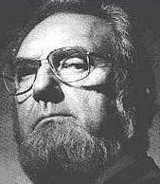
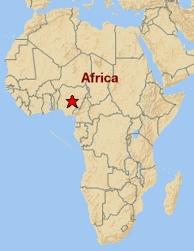
He’s in Nigeria.

What list has Dr. RRK been working on lately?

Her big list of everything that is freaking her out.

